A5 - Compose DB Pokemon

Assignment Submission

By: Connor Goodwin

W#: W0488245

Date: 2025-10-09

* **[20%] Change the DB to list Pokémon characters**. Determine what fields you wish to save for each character (at least these fields, **text**or otherwise, **name**, **number**, **power level**, **description**, **access_count** ...).
* Your App need not allow entry of a new record. Default loading of the DB with insert statements, or a pre-loaded DB is sufficient.

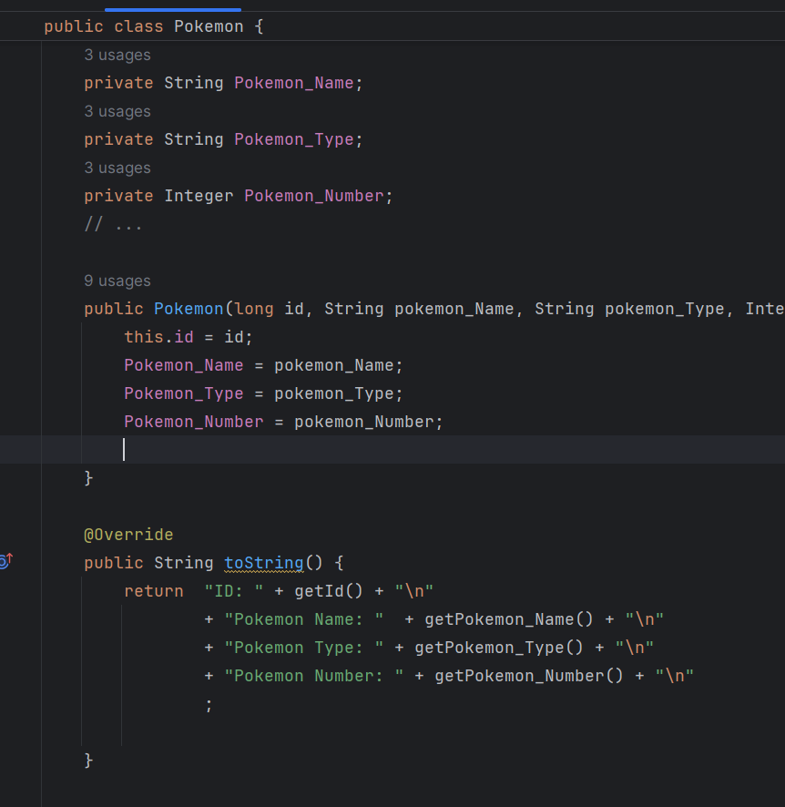

* **[20%] Your compose main screen shows Favorite Pokémon and then the list of Pokémon**. When one Pokémon of the list is selected, it displays details of that Pokémon, and then increments the access count of that Pokémon.

-Did not do

* **[10%] Create at least 6 items in the list**, but there are ways to load the DB in your PC, then upload that DB to the App to easily have all Pokémon....no need for many insert statements.

* **[10%]** **Each access of a record increments an "access_count" field of that Pokémon** .This is how we determine the favorite Pokémon. So going back to the main screen shows the favorite. Also, restarting the App shows the favorite. (note that the fav is the max(access_count) of all the Pokémon)
  + **Did not do**
* **[10%]**Show running of your application on 3 layouts (say; TV, Tablet, Smartphone Portrait, and Smartphone landscape)

* **[30%]** ... max 30%, 5% each change, max 6 changes marked] Make any visible change to the compose screen (color, font, ...)
  + 1. Bold to thin



* + 1. HeadlineMedium to HeadlineLarge



* + 1. Container Color Green to Blue



* + 1. ContentColor Red to Black



* + 1. Padding 12 to 20



* + 1. Stiffness Low to High

